A000-ME-Mesopotamia-Babylonian Incantation bowl with 7 line Aramaic inscription-6th-7th c CE

https://tmpl-resources.auctiva.com/resources/static/images/spacer.gif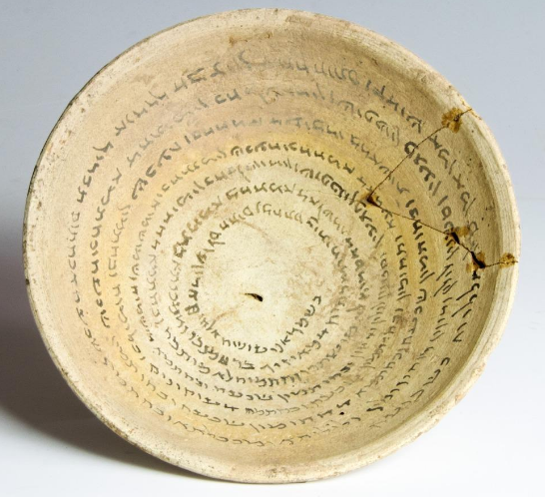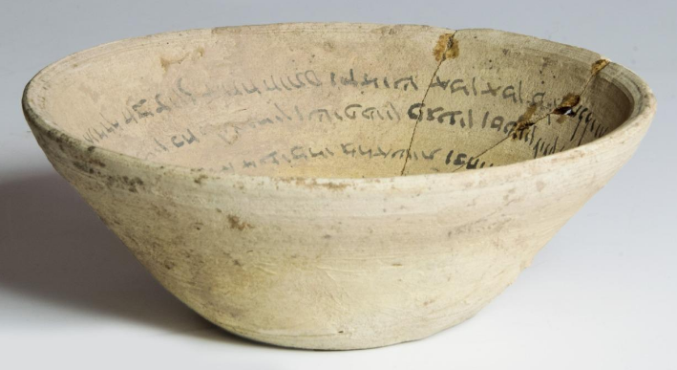

ME-Mesopotamia-Babylonian Incantation bowl with Aramaic inscription-6th-7th c CE 

**Case no.: 3**

**Accession Number:**

**Formal Label:** ME-Mesopotamia-Babylonian Incantation bowl with Aramaic inscription-6th-7th c CE 

**Display Description:**

Cream-colored Incantation bowl with an Aramaic inscription written on the inside in black ink, in a continuous spiral comprising 8 bands of good clear Aramaic script. Such incantations were written individually, according to need and in answer to a specific order placed by a client, executed by a professional, the magician or practitioner. They could be a spell to banish evil spirits, a spell to protect the life of a new-born, a divorce formula, etc. Often biblical verses can be included to those ends. The formulae inscribed on magic bowls represent the only significant epigraphic corpus of Jewish Babylonian Aramaic from this period.

This bowl, made of fired clay. like other similar bowls, has its origin in southern Mesopotamia (southern Iraq and the bordering area of Iran), and it is dated to the sixth century CE. The text is a popular incantation to save some persons that are tormented by harmful ghosts The magical spells during this period in Mesopotamia were inscribed mainly on bowls were written with ink in the inner part of the bowls, sometimes also in the outside, usually creating spiral lines or just concentric circles in independent lines. This inscription starts in the outer concentric circle.

Some bowls have been found in archaeological excavations and certain specific locations, such as the collection from Nippur (Forty, published by Montgomery 1913.) or Khubair, located to the west of the present day Baghdad (Thirty, published by Pognon 1898-1899). However, many of the bowls that we know today have been sold by private individuals and, therefore, we are not sure about their exact origin, although all of them are originally from southern Iraq and the bordering area of Iran

**LC Classification:** PJ5328.4

**Date or Time Horizon:** 600 CE

**Geographical Area:** Basra, southern Iraq. **Basra was founded in** 636 CE. Its name comes from the [Aramaic](https://en.wikipedia.org/wiki/Aramaic) word *basriyatha or basriyi*, meaning "place of huts, settlement".[[4]](https://en.wikipedia.org/wiki/Basra#cite_note-4)

**Map:**

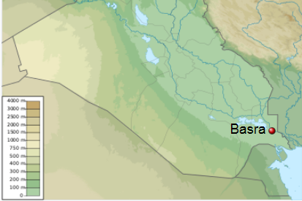

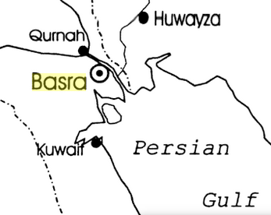

**GPS coordinates:** [30°30′N 47°49′E](https://tools.wmflabs.org/geohack/geohack.php?pagename=Basra&params=30_30_N_47_49_E_region:IQ_type:city(2150000))

**Cultural Affiliation:** Judaeo-Aramaic

**Media:** kaolin clay and charcoal ink

**Dimensions:** Diameter 15.75 cms (6.2 ins)

**Weight:**

**Condition:** One section broken and repaired and complete.

**Provenance:** This item is not a UK find and as such is not subject to the Portable Antiquities Scheme. Purchased from a prominent London dealer and previously reputedly part of a private collection built up in Jordan in the 1930s, exported under license by the Jordanian authorities in 1988  
Supplied with illustrated COA.

**Discussion:**

**THE DEMI-GODS AND DEMONS OF THE TEXT:**

Bagdana, as the "king of demons and Lilits" is called in this text, is a beingfrequently mentioned in the JA(Cf. Sc-ms 16.5 and 8.) and also Syr.' or Mand. (Like the Mand. bowl with a similar form or pattern to this this bowl) bowls. It is sometimes a common name for a group of demons, maybe the group commanded by Bagdana; the group of Bagdana, so to speak(Cf. Sc-gel, lines 5 and 8.). It is a Persian name, *bagdana,* "a temple"(Cf. Naveh-Shaked 1985, p. 205. ). A description of his power and his impressive, terrible figure is provided in ac-ab13: "the Lord Bagdana, powerful, the great one of the gods, and the king, head of sixty kingdoms, whose power is the power of a blast, whose heat (4) is the heat of fire, whose practice is the practice of slaying, whose chastisement is the chastisement of battle, that which is alive he eats, that which is unmixed he drinks. His head is the head of a lion, his molar teeth are the molar teeth of a she-wolf, his teeth are (5) the teeth of a tiger, the draughts of his mouth are furnaces of fire, his eyes are glowing lightnings, his shoulders are the spheres in a cloud, his temples are an anvil of iron, his arms are two hammers, his chest is the chest of an evil man, (6) his belly is a lake without canals, his back is alum, his legs are legs of brass and iron, his sandals are the sandals of sparks, his chariot is the chariot of the evil ones; he comes and in his hand there is a sword of slaying (Cf. Naveh-Shaked 1985, 198-199).

The name of Lilit Hablas has slight spelling variations in the different bowls: *tbs/s* "Habsalas” ( Isb18.4.), *bibs* "Ijalbas"( Isb17.05 and isb20.05) hbls "Hablas"". As we have seen in the aforementioned example, and also in some other similar spells in the bowls discussed later in this paper for comparative purposes, this Lilit represents, together with Bagdana, the most important element of evil. Both of them are malicious beings which have to be dispelled since they are responsible for the dangers affecting the human beings, for whom the spells are written.

The name of Lilit Zarne, *zrny,* is also written in the same way in isb 17.06, isb 18.05 and isb 20.05, but it is written Zarnay, *zrn'y,* in isb 19.03 and 11.

There are also differences in the hero's name, whose famous spear is necessary in order to defeat Hablas: Qatros (Cf. isb17.11; isb19.04 and 11.), Tiqas (Cf. isb18.05) (Cf. Montgomery 1913, texts 32 and 33.) Raqo/is in this text this bowl.07. The blow of his lance is invoked in this spell, like in the similar spells mentioned later, as the effective remedy to mortally wound the heart of Hablas, in a manner similar to the stake driven through the heart of Dracula.

The reference to the letter of divorce we find in the text by which demons are supposed to be moved apart from the persons they harm, seems to have a late Jewish origin. In fact, in the JA bowls the divorce is sometimes associated with a Jewish figure called Yehoshua bar Perahya, although it must be said that this character is also present in other non-JA bowls, such as those in Syr.17. In the text, the letter of divorce is said to be similar to the divorces between demons and their devil-wives.

THE MAGICAL TEXT IN this bowl

After analyzing the different spells in which we find, with the variations already stated, the magical formula used in this bowl, we can make the following conclusions:

1. All of the bowls follow the pattern used in this bowl, but with different elements added.
2. These additions usually give clues about the religious group of the author or the beneficiary of the spell. We have seen, in the texts analysed, that the pattern can be found in a Mand. or a Jewish religious context.
3. In this bowl, we find no clues that might indicate the religious inclination of the author or beneficiary of the spell.

T. Harviainen31 has noted the fact that in many Syr. magic bowls there is no trace pointing to any particular religion. The data about the this bowl just mentioned suggests that the Syr. bowls are not the only bowls which do not contain references to the Mand., Christian or Jewish religions, very popular in southern Mesopotamia at the time these magical texts were written, but the same happens in the JA bowl this bowl.

It is definitely written in the dialect of the Mesopotamian Jews, but this only points at the authorship of the inscription. The Jews seemed to be famous for their capacity to formulate and write this kind of magical text. That might be the reason why most of the bowls are written in JA although this does not mean that the person who requested the spell belonged necessarily to Judaism (See Naveh-Shaked 1985, p. 18).

Therefore, the this bowl text is an example of a spell similar to the incantations in Syr. writing studied by T. Harviainen, where there was no expression that could indicate affiliation to the Christian community, which used, by that time in the Orient, the Syr. language as their own. Those Syriac spells are referred to as the "pagan incantations" by T. Harviainen. We might use the same expression to define the this bowl bowl.

**References:**

Epstein, J.N. 1921. "Gloses babylo-arameenes", *REJ73,* pp. 27-58.

Epstein, J.N. 1922. "Gloses babylo-arameenes", *REJ74,* pp. 40-72.

Geller, M.J. 1986. "Eight Incantation Bowls", *OLP71,* 101-117.

Gordon, Cyrus H. 1934a. "An Aramaic Exorcism", *ArOr6,* 466-474.

Gordon, Cyrus H. 1934b. "An Aramaic Incantation", *AASOR* 14, 141-143.

Hamilton, V.P. 1971. *Syriac Incantations Bowls* (Ph.D. diss, Brandeis University) 1971.

Harviainen, T. 1995. "Pagan Incantations in Aramaic Magic Bowls", *Studia Aramaica* (JSS-Sup. 4), pp. 53-60.

Isbell, Charles D. 1975. *Corpus of the Aramaic Incantation Bowls.* Scholars Press [Serie Dissertation Series 17], Missoula, Montana.

Lidzbarski, Mark. 1902. *Ephemeris fur semitische Epigraphik* I, Giessen.

Montgomery, James A. 1913. *Aramaic Incantations Texts from Nippur* (University of Pennsylvania, The Museum, Publications of the Babylonian Section, vol. Philadelphia.  
Naveh, Joseph - Shaked, Shaul. 1985. *Amulets and Magic Bowls: Aramaic Incantations of Late Antiquity.* Jerusalem‑Leiden.

Naveh, Joseph - Shaked, Shaul. 1993. *Magic spells and formulae: Aramaic incantations of late antiquity.* The Magnes Press, The Hebrew University, Jerusalem

Shaked, Shaul; James Nathan Ford; Siam Bhayro. 2013. *Aramaic bowl spells. Jewish Babylonian Aramaic bowls*.   
Leiden; Boston : Brill. V. 1.

Pognon, Henry. 1898-99 ***Inscriptions*** *mandaites des coupes de Kbouabir,* Paris [Reprinted: Amsterdam 1979].

Yamauchi, Edwin M. 1967. *Mandaic Incantation Texts* [American Oriental Series, 49] New Haven, Connecticut.